**Malaria Day Zero Alert System**

***Technical documents***

***Version 1.0***







Technology developed by

Revision History

|  |  |  |  |
| --- | --- | --- | --- |
| **Version** | **Date** | **Description** | **Author** |
| V1.0 | 01-07-2011 | Created | Ly Channa |
| V1.0 | 15-07-2011 | Review | Rum Sokha |

**TABLE OF CONTENTS**

I- Introduction 3

II- Overview 4

III- Malaria Day Zero Alert System Features 5

IV- Architecture 6

A- Users: 7

B- Report: 8

C- Places: 8

D- Thresholds: 9

E- Settings: 10

VI- Technologies 10

A- jQuery: 10

B- Google map api: 10

C- Ruby: 10

D- Rails: 11

E- MySql: 11

# **I- Introduction**

Malaria Day Zero Alert System is a web base application with SMS service that enable the health center staff (**HC**) and village malaria worker (**VMW**) to send malaria case reporting from the village or health center via SMS to the system and make automatic SMS alert to supervised health center, operational district (OD), Provincial heath department(**PHD**), National Level or System Administrator. Online system also provide ability to view report, manage users and places, set threshold, send alert to group or individual, and templates message setting. The project is currently being hosted with url [**http://md0.cnm.gov.org**](http://md0.cnm.gov.org)

# **II- Overview**

The shift over the last few years away from failing drugs to the highly effective artemisinin-based combination therapies (ACTs) has been a breakthrough, and it was hoped that their design as combinations of two efficacious drugs with different modes of action would preserve them for many years of use.  However, recent evidence suggests that artemisinin tolerant/resistant Plasmodium falciparum parasites are present on the Thai-Cambodian border and it is imperative to mount a vigorous response to stop spread from areas where artemisinin resistance has been identified, whilst simultaneously undertaking further research to define the nature and geographical extent of the problem.

As day-3 reporting model has proved to be an effective mechanism for reporting cases by SMS, and in light of the move towards the elimination of malaria in Cambodia, it has been decided to scale up the system day-0 reporting of all Pf cases from VMWs and health facilities. As the number of cases will be higher for day-0 than day-3 and given the probable need for more widespread implementation it has been decided to move to a more robust internet based platform.

# **III- Malaria Day Zero Alert System Features**

1. Import places(Health clinic and its geographic location information) and users (Village Malaria Worker, Health Center, Operational Disrict, Provincial, National, admin)
2. Custom Alert Message
3. SMS report update from HC and VMW(Village Malaria Worker)
4. Error message back to sender on fail SMS update
5. Log all invalid SMS (error messages)
6. Display Last error SMS received in a day from each number
7. Ability to edit and Mark error message as investigated
8. Set HC threshold rules for alert message to OD
9. Set Village threshold rules for alert message to OD
10. SMS alert setting for Operational District (report every cases or report base on threshold)
11. SMS alert setting for Provincial, National, and Admin
12. Alert message to supervising HC
13. System recognition of SMS report format
14. Listing duplicate SMS report
15. Ability to edit incoming SMS report.
16. Display D0 data aggregation on the map with timeline filtering options
17. View places that have or not have report case

# **IV- Architecture**

# 

**V- Data Model**

Md0 is combined with many different entities shown below:

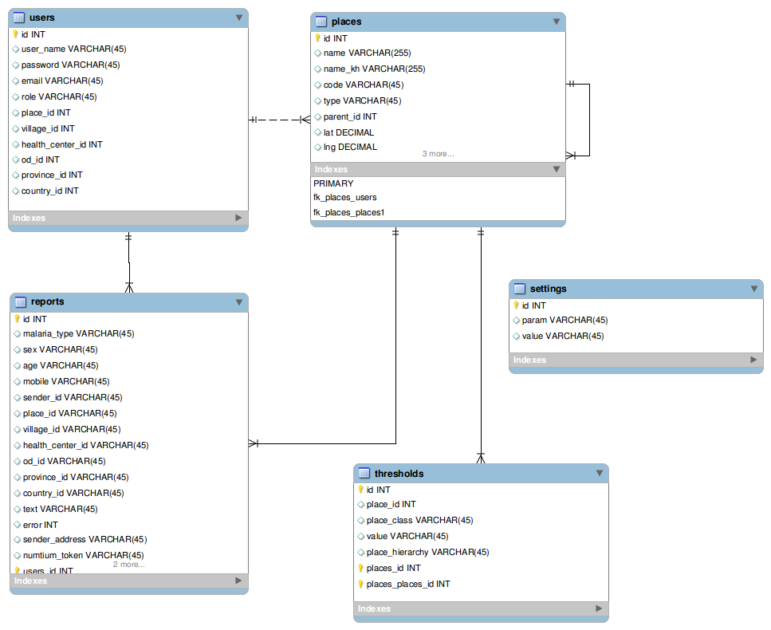

**Figure 1.**

## **A- Users:**

Each represents Md0 user information. Users is located in a specific place and categorized by role. Among many fields in the users table, below are the most important ones:

* + “**place_id**” : identified the place that the user coming from. This field is mandatory when role is default ( if role is national or admin then MD0 does not need to know where the user comes from).
  + **“role” :** Identifies the user role. Md0 devides role into 3 type
    - default : for users from village, health_center , od , province.
    - national: for the national (no place needed)
    - admin : the administrator level to manage Md0 (no place needed) .
  + “**phone_number**” : is used to send and receive message froma and to Md0.
  + “**village_id**” : identified the id of the village the user comes from or allocated to.
  + “**healh_center_id**” : health_center where user allocated. It is the next place hierachy level of village. It is denormalized for reducing sql.
  + “**od_id**” : od where user allocated. It is the next place hierachy level of Health center. It is denormalized for reducing sql.
  + “**province_id**” : province_id where user allocated. It is the next place hierachy level of Od. It is denormalized for reducing sql.

## **B- Report:**

User from a village can send many reports about his village or other village. With this requirement Md0 connects the user table with reports table in which has the following important fields.

* “malaria_type”: identifies the type of malaria (F,V,M).
* “sex” : sex of the patient
* age : the age of the patient
* mobile : is a mobile patient.
* sender_id : the user who informs this report, normally village malaria worker or health center staff .
* place_id: the village which the patient come from.
* village_id: same as place_id
* health_center_id, od_id, province_id are the heath center, od, province where the patient comes from consequently.
* text : the whole informed message. It is in raw format that was sent . Ej “**F12M.**” .
* error: indicates if the report is error. 1 if incorrect otherwise correct.
* sender_address: the full quilified phone_number of the user who sends the report.

## **C- Places:**

Village malaria workers or health center staffs are allocated in a specific place and can send report from as many places as possible. The classic structures of the place administrative hierarchies should look something similar to the following diagram:

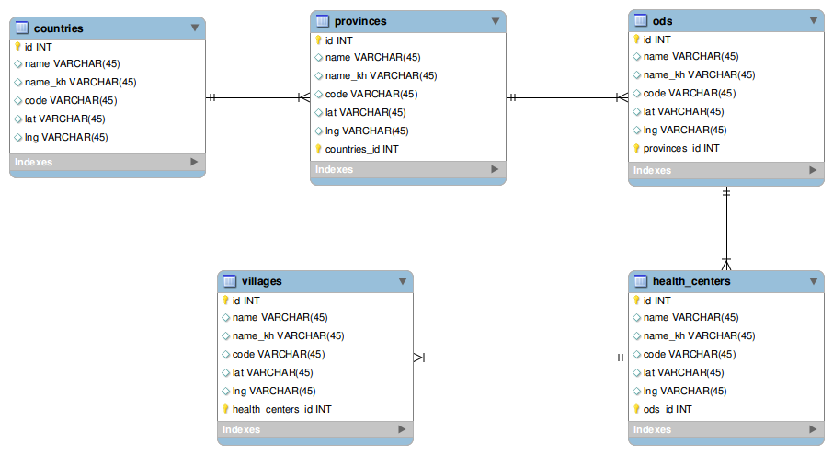

Md0 makes use of single table inheritance in rubyonrails so it can be reduced to just one “places” table in the figure 1 which composed of the following field:

* name : Place name
* name_kh: place name in khmer language
* code : place code
* lat : latitude of the place (used to show on map in combination with lng)
* lng : longitude of the place (used to show on map in cambonation with lat)
* type : type of entity (created by rubyrails)
* parent_id : id of the parent place (created by rubyonrails) ej: if a place is a village then the “type” column value will be “Village” and the parent_id will be id of the Health center that the village belongs to.
* hierachy : the full path of places to the last ancestors.

## **D- Thresholds:**

Threshold is a restriction that can be set to restrict how the reporting message will be spread out to the upper level. Check the user manual for the use of thresholds. The thresholds table composes of the following field:

* place_id : identified the place that thresholds is being set
* place_class : identified the place type (Village, HealthCenter, Od , Province, … )
* value : number value of thresholds to start spreading to upper level.

## **E- Settings:**

Setting is key, value paircontains the core setting of Md0 including:

1. custom alert
2. template setting...

# **VI- Technologies**

Language : [Ruby 1.9.2](http://www.ruby-lang.org/en/) .

Framework : [Rails 3.0.6](http://rubyonrails.org/).

Database : [Mysql](http://www.mysql.com/).

Javascript : [jQuery](http://www.jquery.com).

Map : [Google map api V3](http://code.google.com/apis/maps/documentation/javascript/reference.html).

Messaging : [Instedd numtiun messaging platform](http://code.google.com/p/nuntium/).

## **A- jQuery:**

A fast, concise, library that simplifies how to traverse HTML documents, handle events, perform animations, and add AJAX.

jQuery is being use in replacement of plain javascript with a couple of plugins like :

1. Facybox
2. jQuery UI : slider
3. Autocomplete from http://www.devbridge.com/projects/autocomplete/jquery/ .
4. Customizing jquery UI slide to support in different time frame with MD.visualize.slider
5. jQuery UI calendar.
6. Enhance user experience with ajax.

## **B- Google map api:**

Google map API v3 for map interaction.

Marker with label google map v3 library

## **C- Ruby:**

A dynamic, interpreted, open source programming language with a focus on simplicity and productivity.

## 

## **D- Rails:**

It is full stack, Open source web application framework optimized for sustainable programming productivity, allows writing code by favoring convention over configuration. The following gems is used along with rails to get work done:

* + gem jquery-rails : used jquery in rails instead of prototype
  + gem nuntium-api : to make communication with nuntium server
  + gem will_paginate : paginate active record query interface.
  + gem devise : user authentication

## **E- MySql:**

The MySQL database has become the world's most popular open source database because of its high performance, high reliability and ease of use. It is also the database of choice for a new generation of applications built on the LAMP stack used by many of the world's largest and fastest-growing organizations.